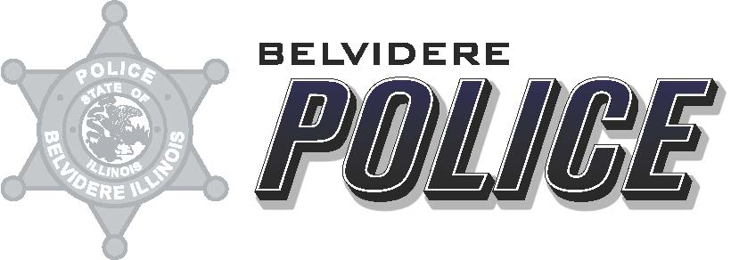

Date: February 2, 2024
From: Deputy Chief Matthew Wallace
To: ILETSB
Re: Camera Grant FY19 report

Attached are the reporting questions requested as a part of the ILETSB Camera Grant Award for year 2023.
- The Belvidere Police Department received 5 in-car cameras as a part of the ILETSB 2018 Camera Grant.
- The Belvidere Police Department received 15 in-car cameras as a part of the ILETSB 2019 Camera Grant.
- The Belvidere Police Department currently uses 43 Body Worn Cameras.
- The Belvidere Police Department had all 5 cameras installed in squad cars during the year 2018. The Belvidere Police Department had all 15 cameras installed in squad cars during the year 2019.
- The Belvidere Police Department had all 43 Body Worn Cameras implemented during the year 2023.
- The supervisors and administrators of the Belvidere Police Department utilize the In- Car cameras to review Use of Force, to review all pursuits, any officer complaints/ Internal Investigations, and as a general review of officer interaction with the public.
- The supervisors and administration of the Belvidere Police Department utilize the Body Worn Cameras following the laws of the State of Illinois. They are used as evidence in criminal cases. The videos are not reviewed for discipline purposes unless citizen complaints are filed.
- See Attached Excel spreadsheet.
- N/A

Respectfully Submitted,
Matthew R. Wallace
Deputy Chief
Belvidere Police Department

