LESLIE H. VANCIL 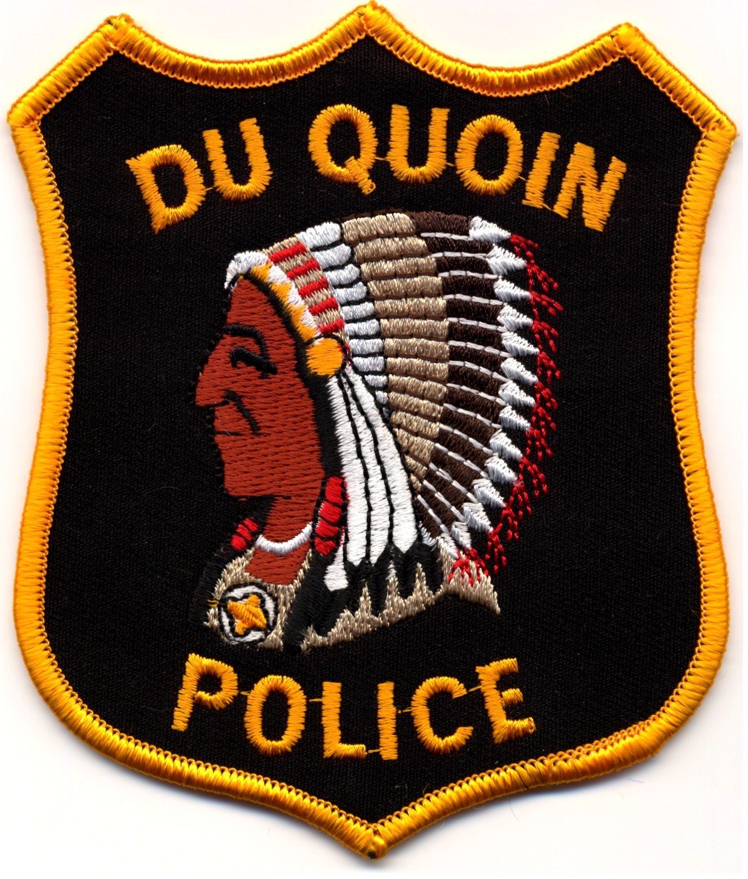 MICHAEL A. WARD
CHIEF OF POLICE POLICE COMMISSIONER
Office: (618) 542-2131 Fax: (618) 542-4014
CITY OF DU QUOIN
POLICE DEPARTMENT
304 E. Poplar St.
Du Quoin, IL 62832

Officer Worn Body Camera Report
Du Quoin Police Department

Number of Officer in the Department: 10
Number of Part-Time Officers: 6
Number of Cameras received: 11

The only technical issue we have had with the Officer Worn Body Cameras has been the date being wrong during download. After the camera has been downloaded, the issue is resolved on its own.

Videos are randomly reviewed by supervisors within the department. Supervisors also review video when copies are made for prosecution.

Chief Les Vancil
Du Quoin Police Department

To Serve and Protect

