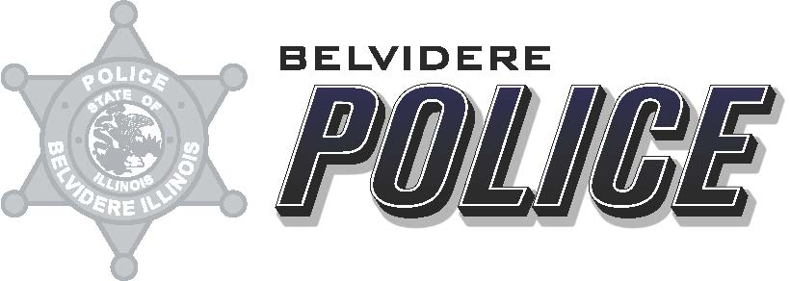

Date: April 15, 2021
From: Deputy Chief Matthew Wallace
To: ILETSB
Re: Camera Grant FY20 report

The answers to the required reporting instructions for 2020 are as follows:
- The Belvidere Police Department received 5 in-car cameras as a part of the ILETSB 2018 Camera Grant. The Belvidere Police Department received 15 in-car cameras as a part of the ILETSB 2019 Camera Grant.
- The Belvidere Police Department had all 5 cameras installed in squad cars during year 2018. The Belvidere Police Department had all 15 cameras installed in squad cars during year 2019.
- The supervisors and administrators of the Belvidere Police Department utilizes these cameras to review Use of Force, to review all pursuits, any officer complaints/ Internal Investigations, and as a general review of officer interaction with the public.
- See Attached Excel spreadsheet.
- N/A

Respectfully Submitted,

Matthew R. Wallace
Deputy Chief
Belvidere Police Department

