Section 1070.Appendix A Post-Unsatisfied Judgment Action Form
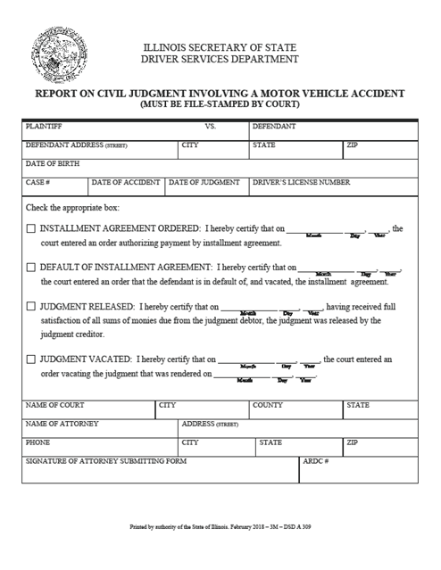

(Source: Added at 42 Ill. Reg. 16552, effective August 23, 2018)

