Section 1010.APPENDIX D Specialty License Plates Request Form

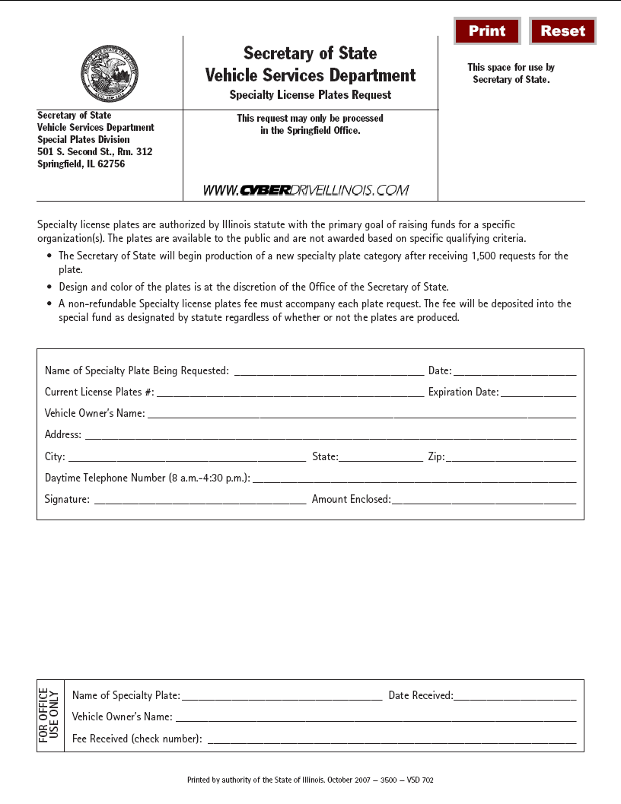

(Source: Added at 32 Ill. Reg. 17253, effective October 15, 2008)

