Section 1010.APPENDIX C Affirmation Supporting Salvage Certificate

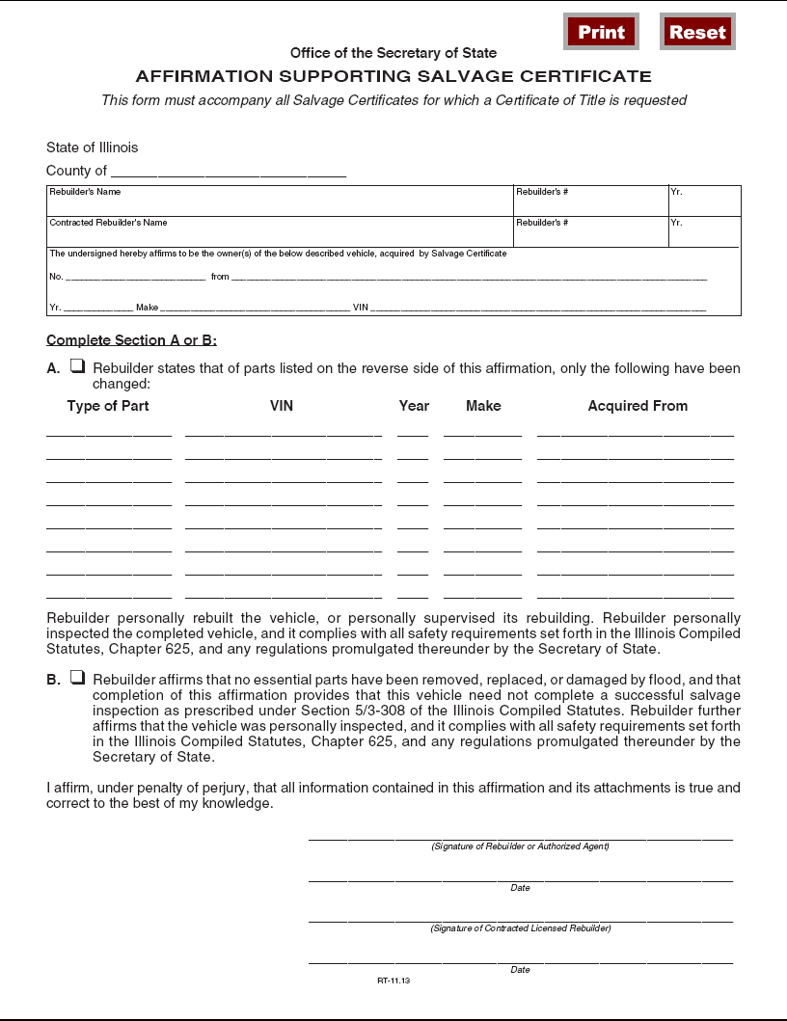

CODE FOR ESSENTIAL PARTS LIST

A. | Right front fender/rear fender
B. | Left front fender/rear fender
*C. | Right rear quarter panel/bed slide
*D. | Left rear quarter panel/bed slide
E. | Hood
F. | Right front door
G. | Right rear door
H. | Left front door
I. | Left rear door
J. | Hatchback/deck lid/tailgate/trunk lid
K. | Right T-top
L. | Left T-top
M. | Moon roof/sunroof/astro body
N. | Front end assembly (headlights – fenders − hood)
O. | Front clip (FEA – with cowl attached)
P. | Rear clip (quarter panels – fenders – floor – top)
Q. | Clip cab (roof – back panel − floor)
R. | Cab (clip cab – with cowl)
*S. | Bed
T. | Frame
U. | Engine
*V. | Transmission
W. | Cowl
X. | Transmission (Second Division)
Y. | Aluminum wheels
Z. | Chassis/shell/hulk

SEATS |  | RADIOS |  | MOTORCYCLES
AA. | Front seat | AG. | Cassette/compact disc | *AP. | Faring
AB. | Rear seat | AH. | Cassette radio | *AQ. | Fuel tanks
AC. | Left front seat | AI. | Compact disc changer | *AR. | Fork
AD. | Right front seat | AJ. | Compact disc player
AE. | Left rear seat | AK. | Compact disc radio
AF. | Right rear seat | AL. | Stereo radio (AM/FM)
 |  | *AM. | Front bumper (NHTSA veh)
 |  | *AN. | Rear bumper (NHTSA veh)

*Not considered essential parts, may be inspected as part of the Salvage Vehicle Inspection Program.

(Source: Added at 32 Ill. Reg. 17253, effective October 15, 2008)

