Section 443.ILLUSTRATION A Stop Signal Arm Panels

Octagon Shaped Semaphore (see Section 443.APPENDIX J (a))

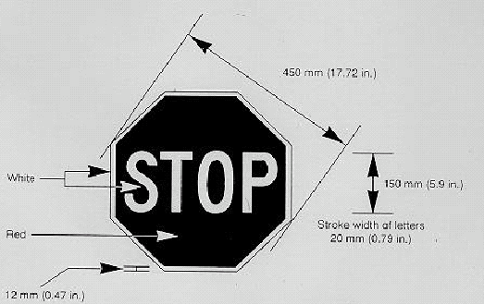

Hexagon Shaped Semaphore (see Section 443.APPENDIX J (a))

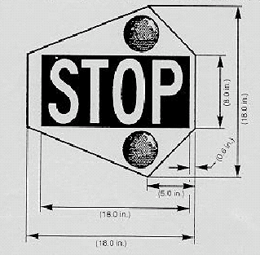

(Source: Amended at 22 Ill. Reg. 15371, effective August 7, 1998)

