Section 441.ILLUSTRATION A Stop Arm Panels

Octagon Shaped Semaphore (see Section 441.Appendix J(a))

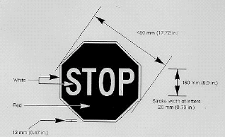

Hexagon Shaped Semaphore (see Section 441.Appendix J(a))

