Section 440.ILLUSTRATION C Exhaust Discharge Prohibited Zones

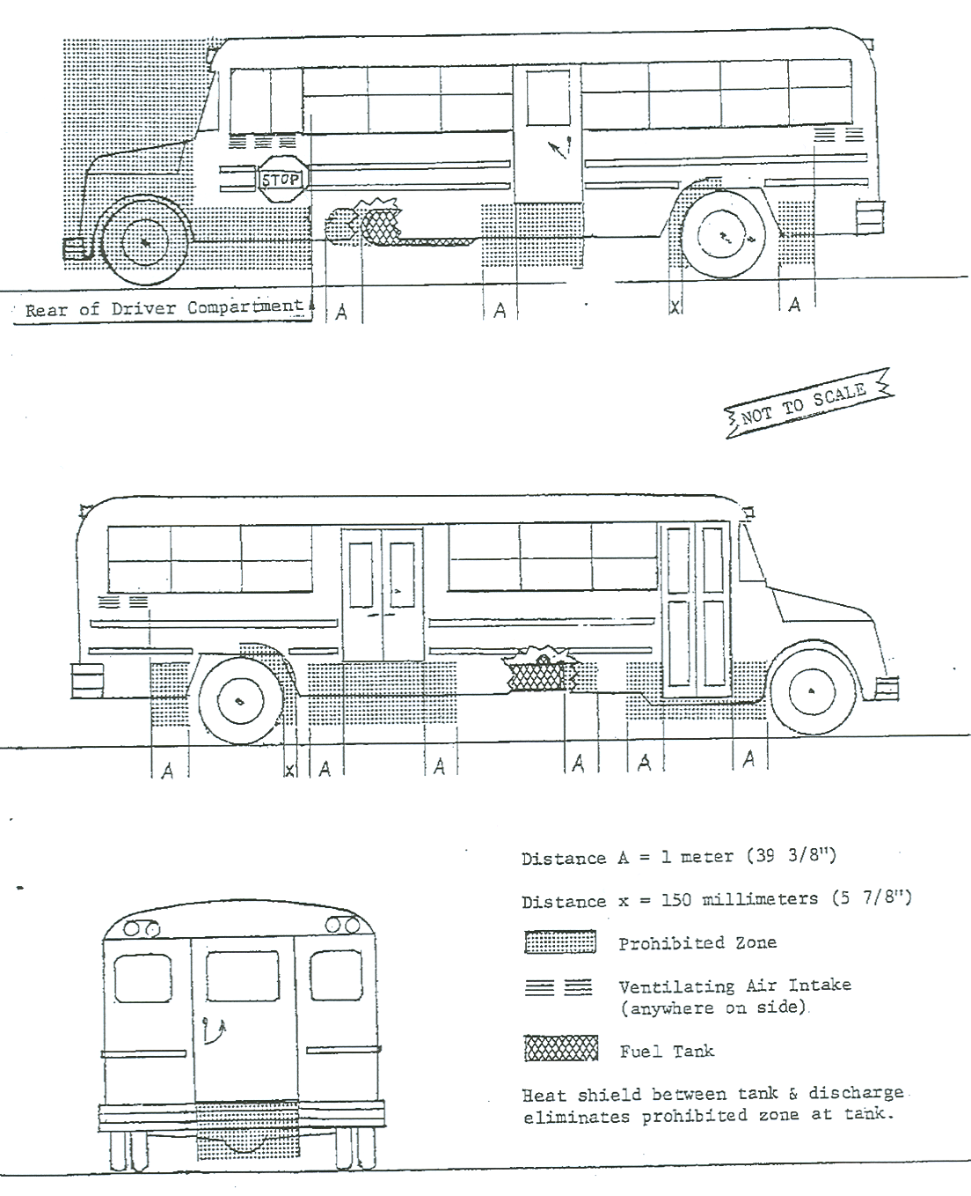

(Source: Amended at 32 Ill. Reg. 17983, effective November 10, 2008)

