Section 440.ILLUSTRATION B Octagon Shaped Stop Signal Arm Panel

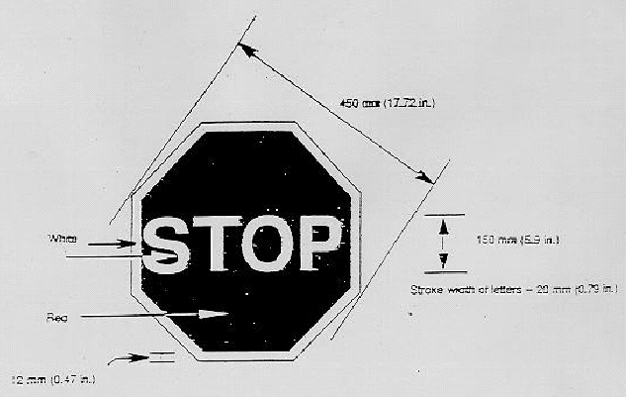

(Source: Amended at 22 Ill. Reg. 19354, effective October 15, 1998)

