Section 14.APPENDIX E Restricted Landing Areas Standards

Section 14.ILLUSTRATION D Ultralight/STOL Restricted Landing Areas Minimum Separation & Gradient Standards

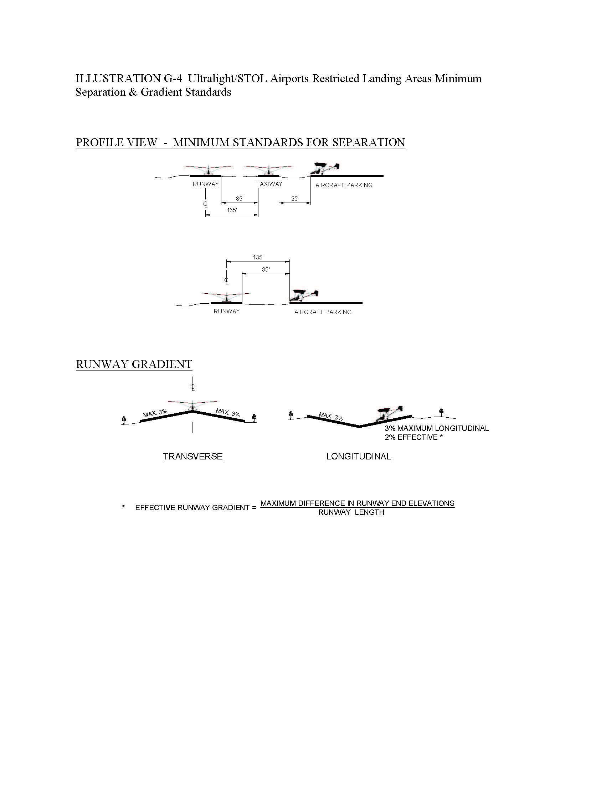

(Source: Old Illustration D renumbered to Appendix E, Illustration F and new Illustration D added at 38 Ill. Reg. 20064, effective October 2, 2014)

