Section 14.APPENDIX E Restricted Landing Areas Standards

Section 14.ILLUSTRATION E Restricted Landing Areas Displaced Threshold Markings

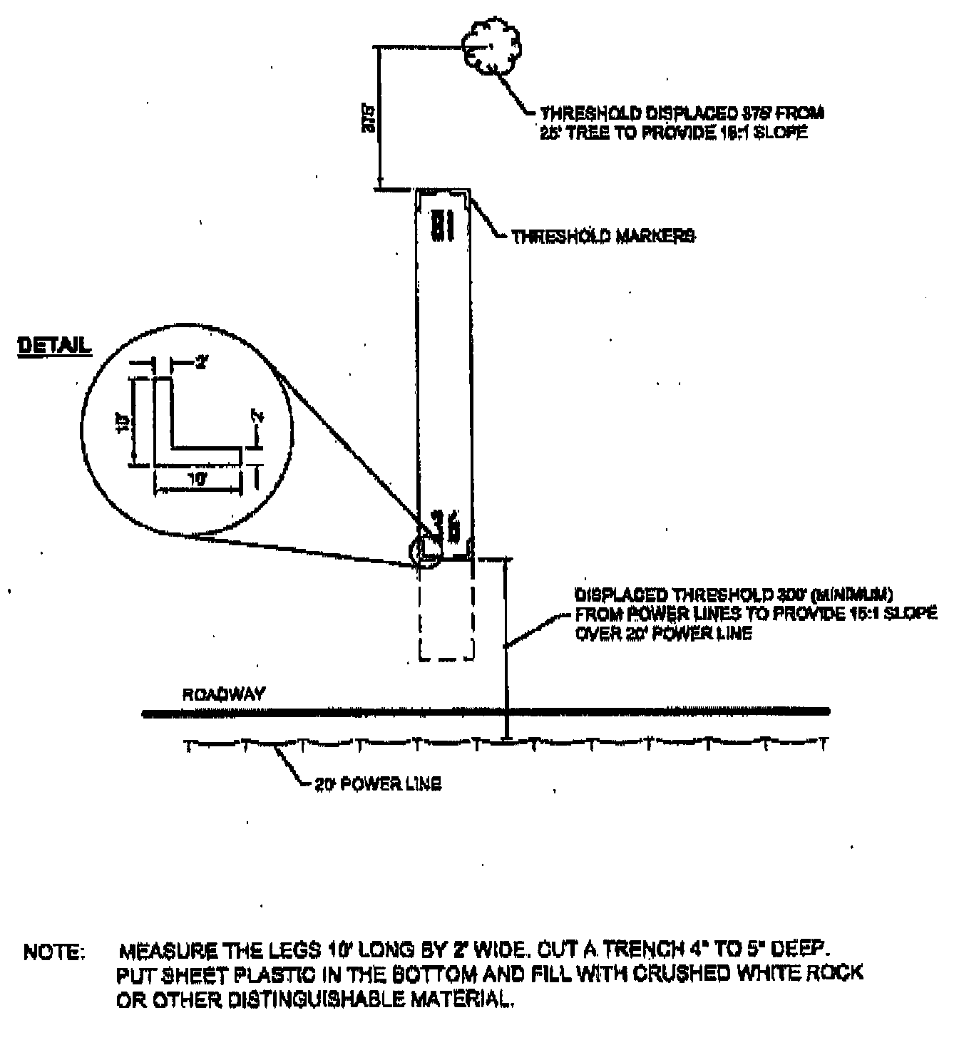
(Source: Renumbered from Appendix E, Illustration C at 38 Ill. Reg. 20064, effective October 2, 2014)

