Section 14.APPENDIX E Restricted Landing Areas Standards

Section 14.ILLUSTRATION C Ultralight/STOL Restricted Landing Areas Minimum Dimensional Standards

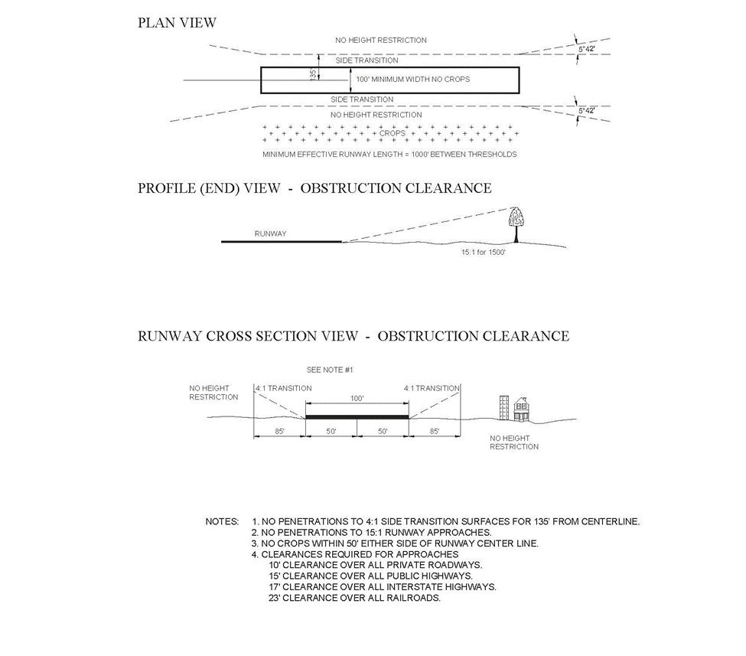

(Source: Old Illustration C renumbered to Appendix E, Illustration E and new Illustration C added at 38 Ill. Reg. 20064, effective October 2, 2014)

