Section 14.APPENDIX E Restricted Landing Areas Standards

Section 14.ILLUSTRATION A Restricted Landing Areas Minimum Dimensional Standards

Section 14.APPENDIX E Restricted Landing Areas Standards

Section 14.ILLUSTRATION B Restricted Landing Areas Minimum Separation & Gradient Standards

Section 14.APPENDIX E Restricted Landing Areas Standards

Section 14.ILLUSTRATION C Restricted Landing Areas Displaced Threshold Markings

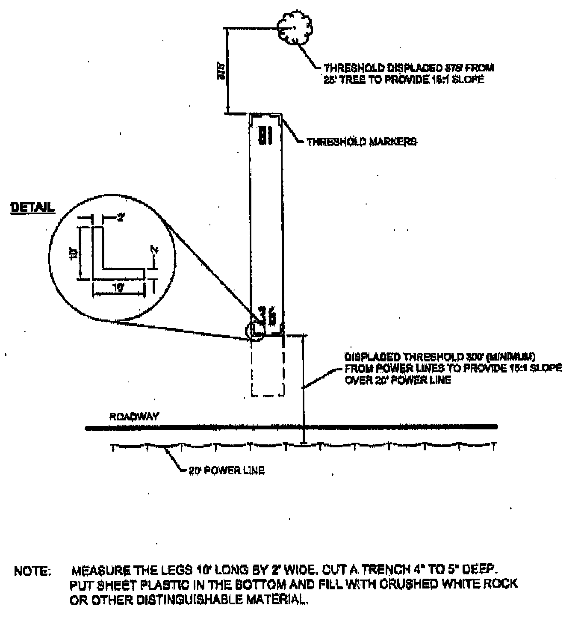
Section 14.APPENDIX E Restricted Landing Areas Standards

Section 14.ILLUSTRATION D Restricted Landing Areas Closed RLA & Closed Runway Marker

