Section 905.APPENDIX A Illustrations and Exhibits

Section 905.ILLUSTRATION J Septic Tank Subsurface Seepage Field

Section 905.EXHIBIT A Plan View – Gravel System

(Source: Amended at 27 Ill. Reg. 2431, effective March 15, 1996)
Section 905.APPENDIX A Illustrations and Exhibits

Section 905.ILLUSTRATION J Septic Tank Subsurface Seepage Field

Section 905.EXHIBIT B Section View – Gravel System

(Source: Amended at 27 Ill. Reg. 2431, effective March 15, 1996)

Section 905.APPENDIX A Illustrations and Exhibits

Section 905.ILLUSTRATION J Septic Tank Subsurface Seepage Field

Section 905.EXHIBIT C Plan View – Gravelless and Chamber System

Building sewer
Septic tank
Point of entry to seepage field
100 feet maximum from point of entry.
7 to 9 Feet minimum separation distance see Appendix A, Illustration I, Exhibit D
Plan view
5 feet
Building drain
Building foundation
Gravelless pipe or Chamber system

(Source: Amended at 37 Ill. Reg. 14994, effective August 28, 2013)

Section 905.APPENDIX A Illustrations and Exhibits

Section 905.ILLUSTRATION J Septic Tank Subsurface Seepage Field

Section 905.EXHIBIT D Section View – Gravelless and Chamber System

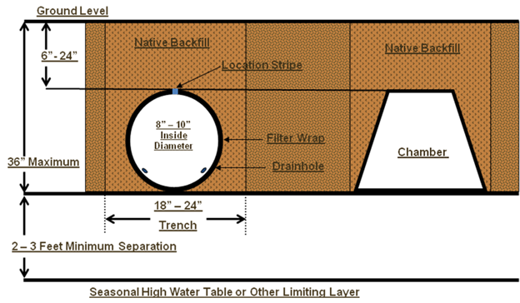

(Source: Amended at 37 Ill. Reg. 14994, effective August 28, 2013)

