Section 890.APPENDIX K Illustrations for Subpart K

Section 890.ILLUSTRATION Z Dual Branches

(Referenced in Section 890.1520(b))

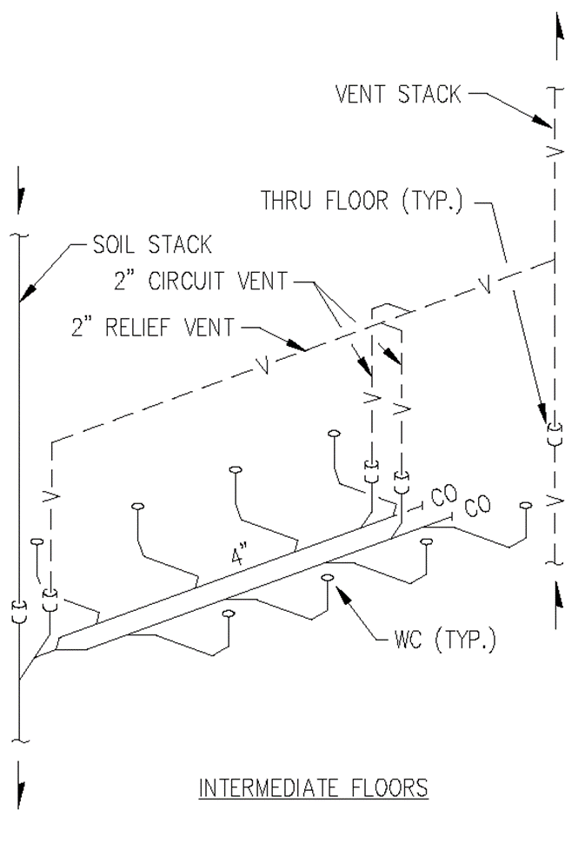

(Source: Amended at 38 Ill. Reg. 9940, effective April 24, 2014)
Section 890.APPENDIX K Illustrations for Subpart K

Section 890.ILLUSTRATION AA Right and Wrong Vent Connections

(Referenced in Sections 890.1450(b) and 890.1520(c))

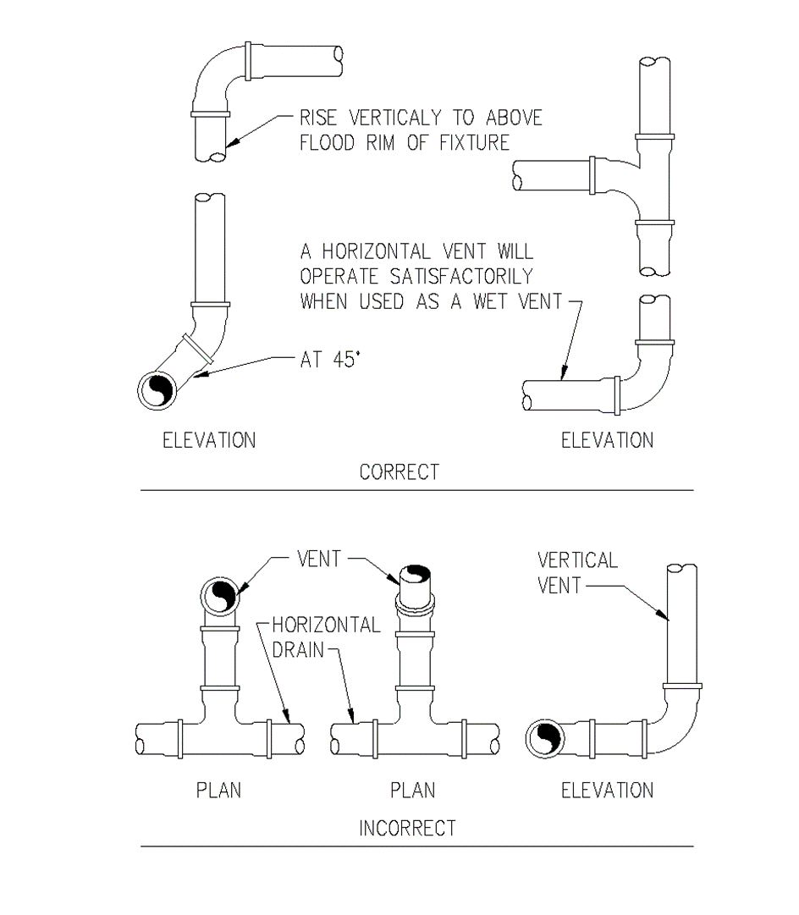

(Source: Amended at 38 Ill. Reg. 9940, effective April 24, 2014)
Section 890.APPENDIX K Illustrations for Subpart K

Section 890.ILLUSTRATION BB Fixtures Back-to-Back in Battery

(Referenced in Section 890.1520(d))

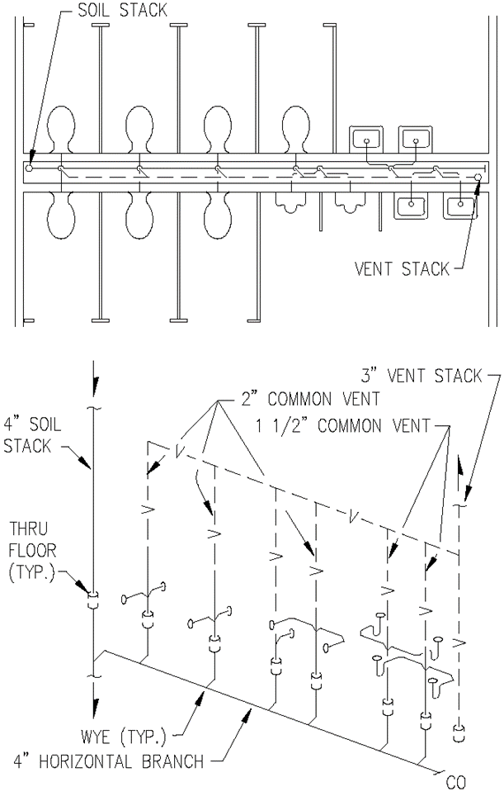

(Source: Amended at 38 Ill. Reg. 9940, effective April 24, 2014)
Section 890.APPENDIX K Illustrations for Subpart K

Section 890.ILLUSTRATION CC Fixture Connections-Offset Vents

(Referenced in Sections 890.1520(e) & 890.1550(a))

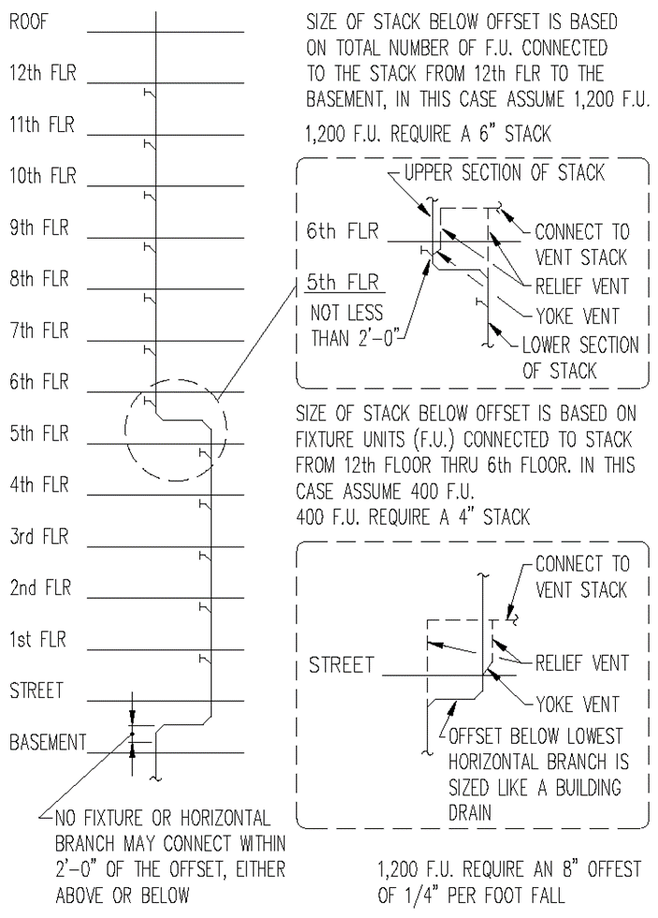

(Source: Amended at 38 Ill. Reg. 9940, effective April 24, 2014)
Section 890.APPENDIX K Illustrations for Subpart K

Section 890.ILLUSTRATION DD Circuit Vented Fixtures

(Referenced in Section 890.1520(f))

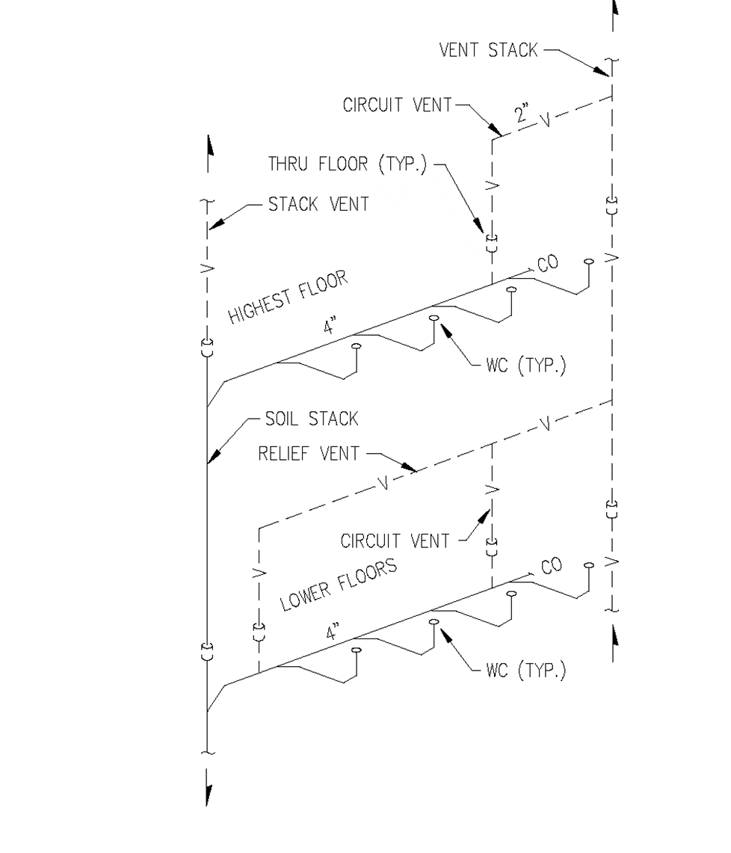

(Source: Amended at 38 Ill. Reg. 9940, effective April 24, 2014)
Section 890.APPENDIX K Illustrations for Subpart K

Section 890.ILLUSTRATION EE Vent Stacks

(Referenced in Section 890.1450(e))

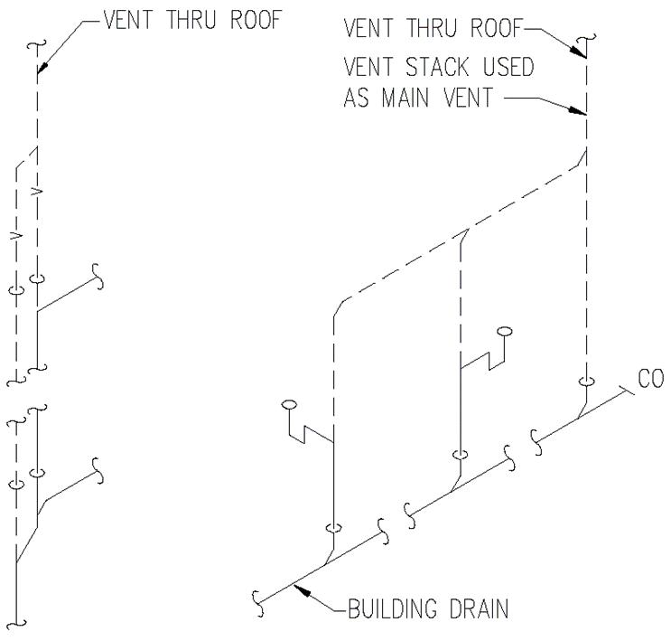

(Source: Amended at 38 Ill. Reg. 9940, effective April 24, 2014)
Section 890.APPENDIX K Illustrations for Subpart K

Section 890.ILLUSTRATION FF Combination Waste and Vent

(Referenced in Section 890.1590(d))

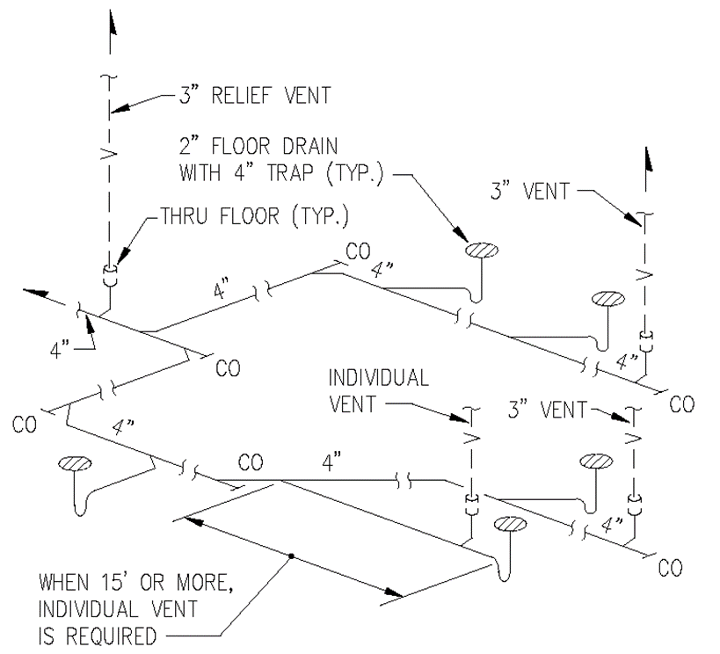

(Source: Amended at 38 Ill. Reg. 9940, effective April 24, 2014)
Section 890.APPENDIX K Illustrations for Subpart K

Section 890.ILLUSTRATION GG Special Venting for Island Fixtures

(Referenced in Section 890.1600(b))

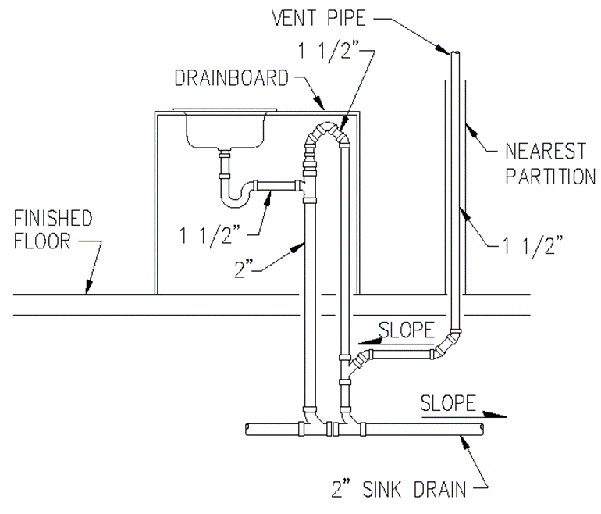

(Source: Amended at 38 Ill. Reg. 9940, effective April 24, 2014)

