Section 890.APPENDIX K Illustrations for Subpart K

Section 890.ILLUSTRATION Y Battery Venting

(Referenced in Section 890.1520(a) and (e))

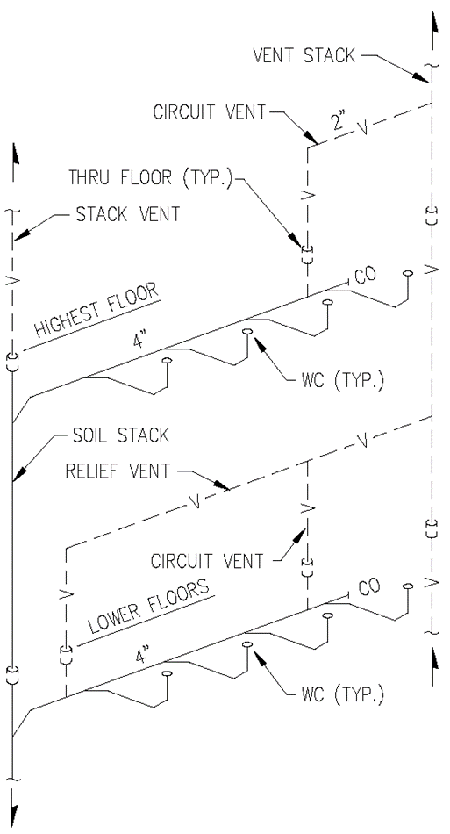

(Source: Amended at 38 Ill. Reg. 9940, effective April 24, 2014)

