Section 890.APPENDIX K Illustrations for Subpart K

Section 890.ILLUSTRATION F Vent Grade and Vertical Rise

(Referenced in Section 890.1450(a) and (b))
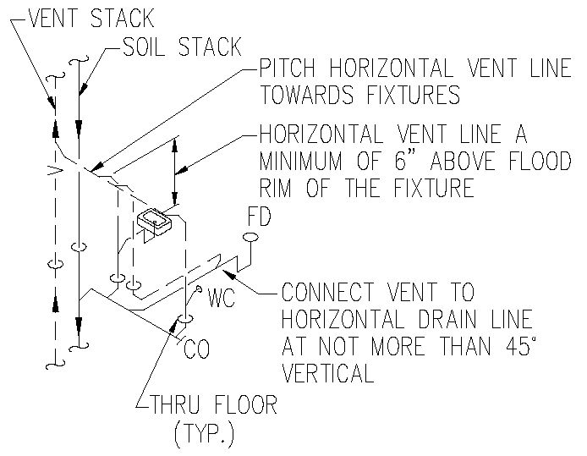

(Source: Amended at 38 Ill. Reg. 9940, effective April 24, 2014)

