Section 890.APPENDIX I Illustrations for Subpart I

Section 890.ILLUSTRATION N P & T Valve Installed in Hot Outlet Line

(Referenced in Section 890.1230(c)(2))
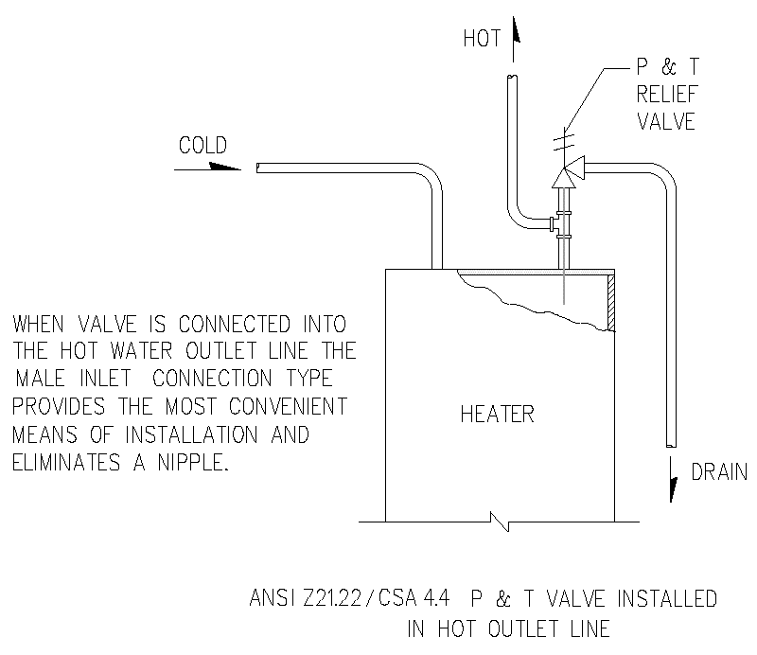

(Source: Amended at 38 Ill. Reg. 9940, effective April 24, 2014)

