Section 890.APPENDIX I Illustrations for Subpart I

Section 890.ILLUSTRATION J Separate Controls for Each Family Unit

(Referenced in Section 890.1190(e))

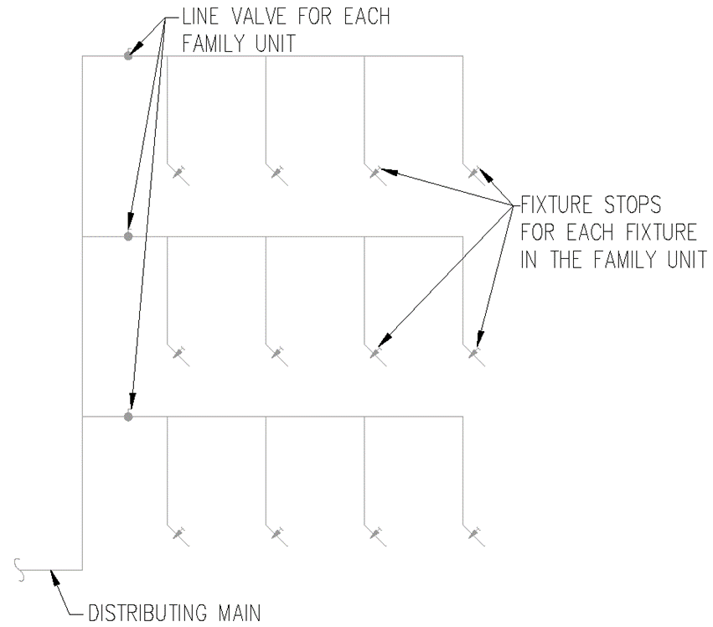

(Source: Amended at 38 Ill. Reg. 9940, effective April 24, 2014)

