Section 890.APPENDIX H Illustrations for Subpart H

Section 890.ILLUSTRATION C Indirect Waste Piping #3

(Referenced in Section 890.1010(a))

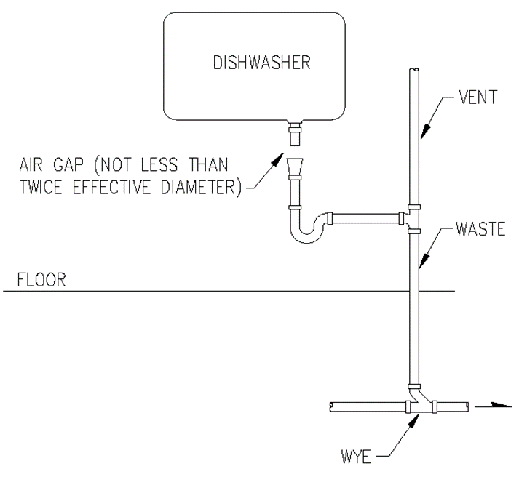

(Source: Amended at 38 Ill. Reg. 9940, effective April 24, 2014)

