Section 890.APPENDIX F Illustrations for Subpart F

Section 890.ILLUSTRATION D Commercial-Type Grinder

(Referenced in Section 890.710(b))

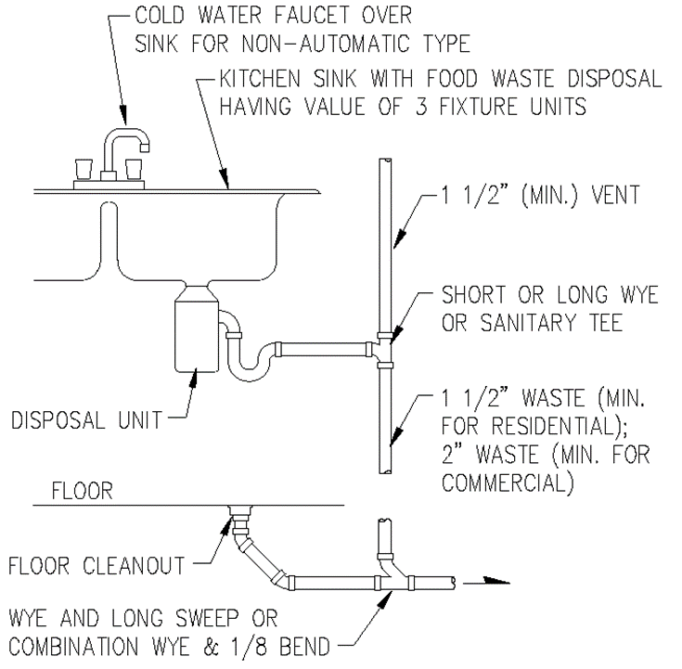

(Source: Amended at 38 Ill. Reg. 9940, effective April 24, 2014)

