Section 890.APPENDIX E Illustrations for Subpart E

Section 890.ILLUSTRATION B Typical Grease Interceptor/Catch Basin

(Referenced in Section 890.510)
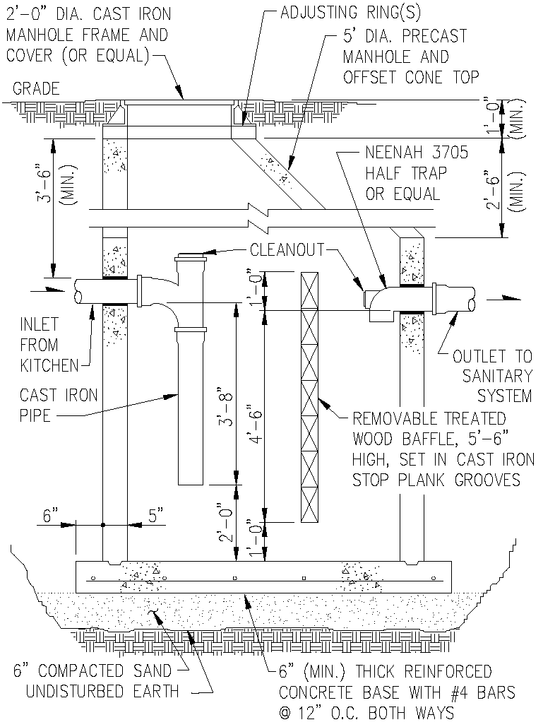

(Source: Amended at 38 Ill. Reg. 9940, effective April 24, 2014)

