Section 890.APPENDIX E Illustrations for Subpart E

Section 890.ILLUSTRATION A Grease Interceptor

(Referenced in Section 890.510)

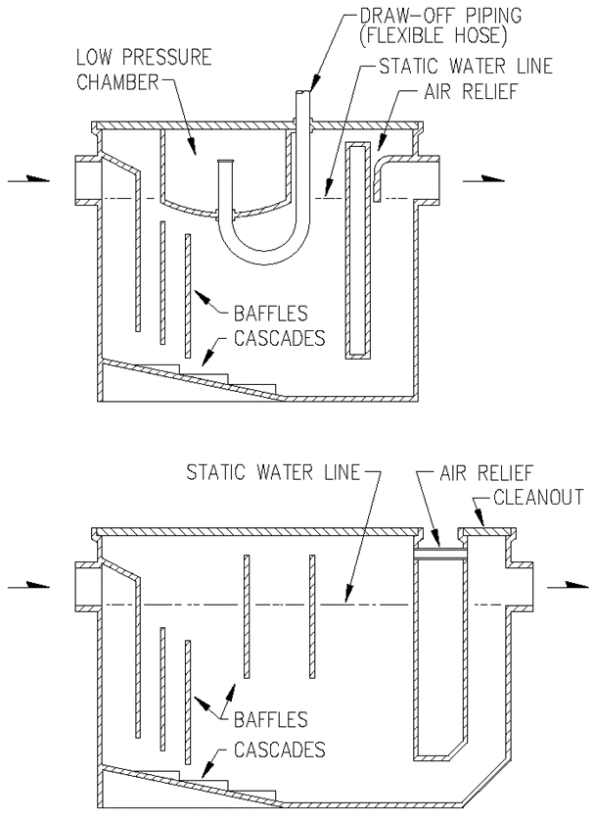

(Source: Amended at 38 Ill. Reg. 9940, effective April 24, 2014)

