Section 890.APPENDIX D Illustrations for Subpart D

Section 890.ILLUSTRATION E Prohibited Traps

(Referenced in Section 890.410(k))

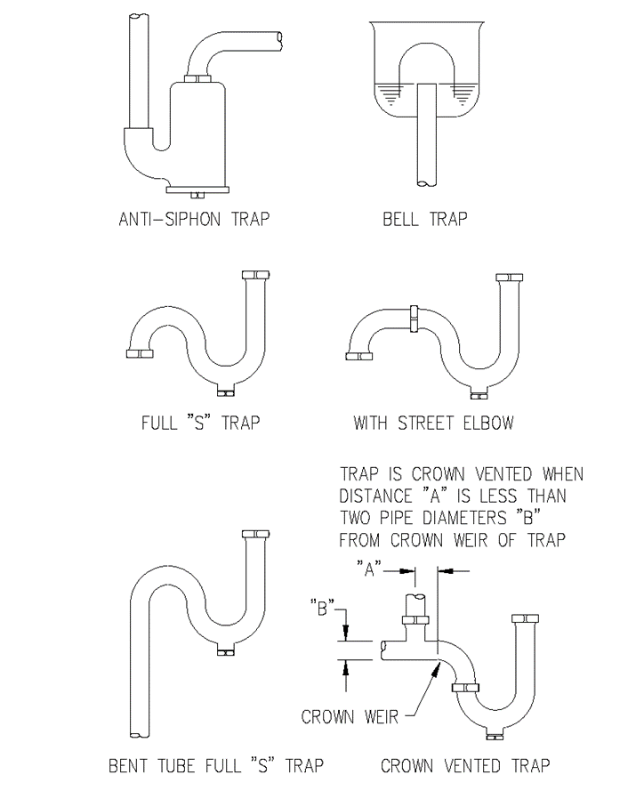

(Source: Amended at 38 Ill. Reg. 9940, effective April 24, 2014)

