Section 820.APPENDIX A Illustrations

Section 820.ILLUSTRATION J Installation of a Pressure Diatomaceous Earth Filter System

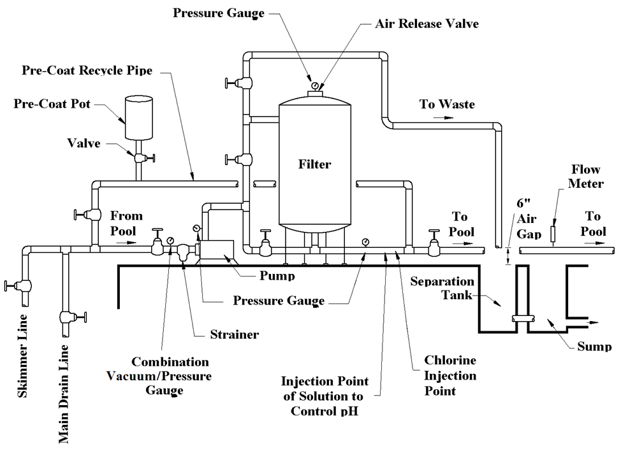

(Source: Amended at 37 Ill. Reg. 16539, effective October 4, 2013)

