Section 1050.ILLUSTRATION A Map of Regions

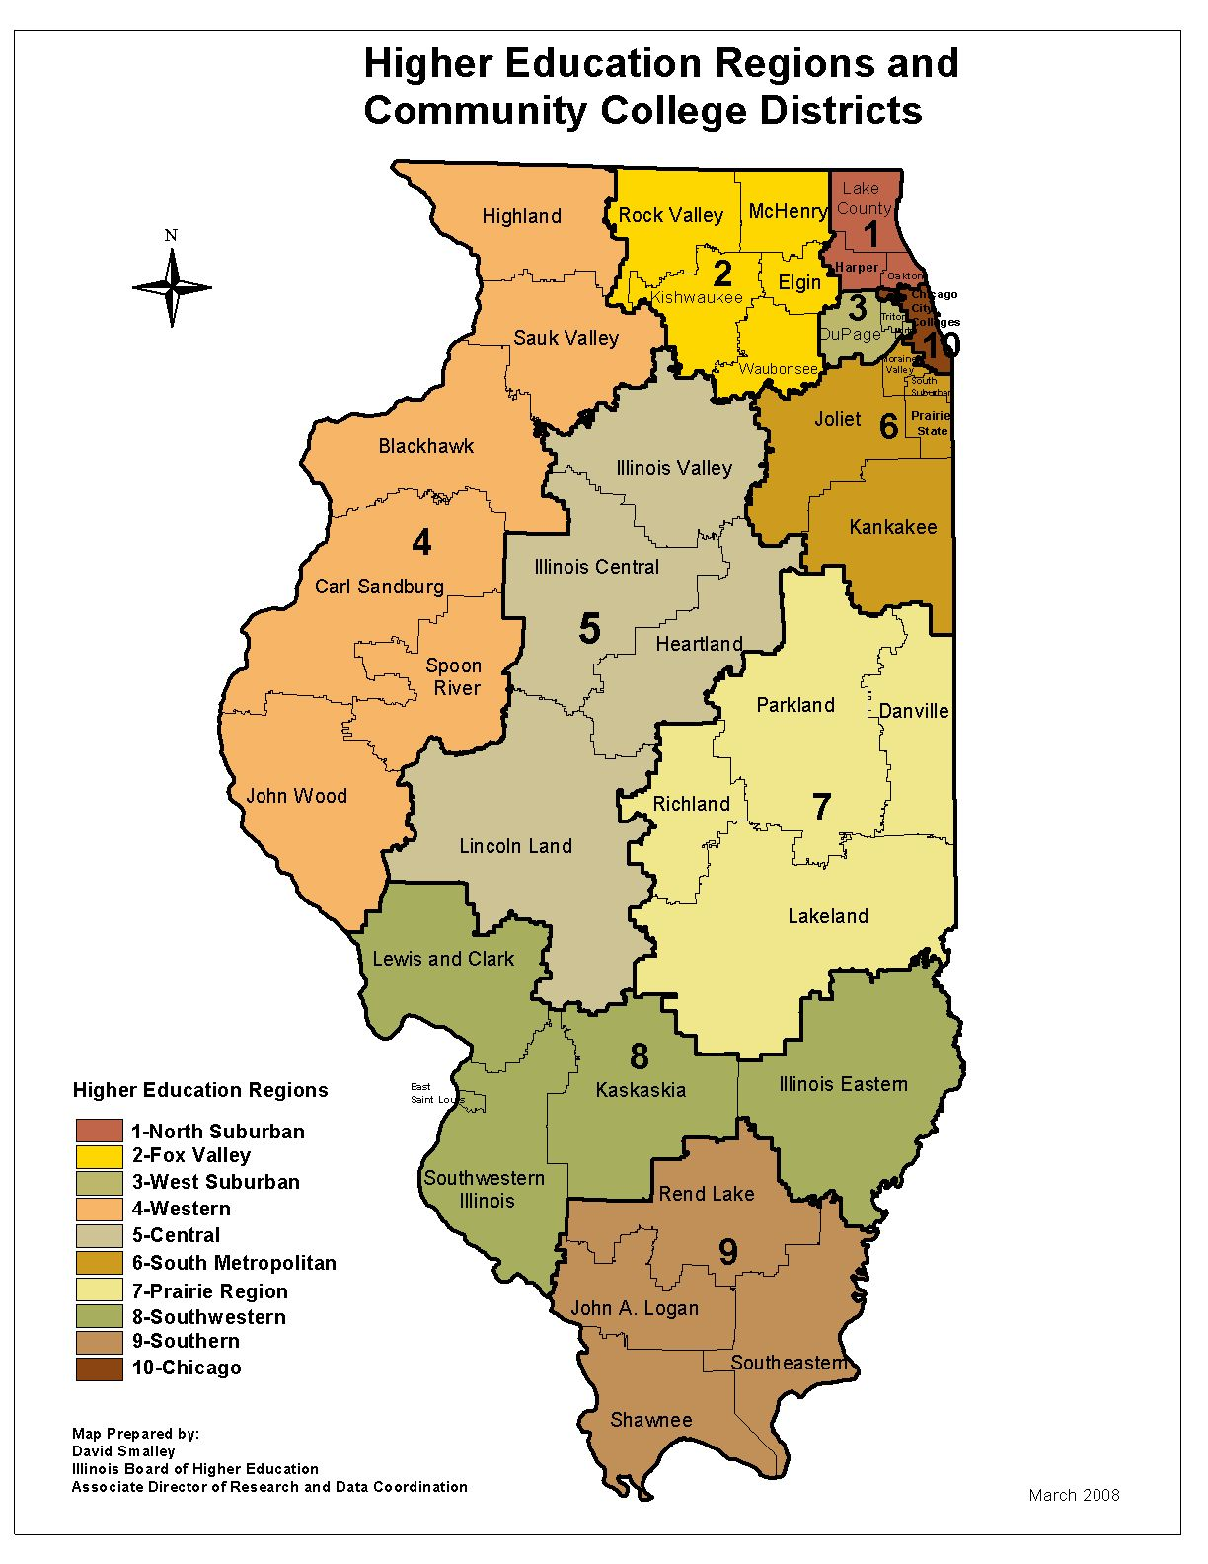

(Source: Added at 32 Ill. Reg. 78, effective December 23, 2008)

