Section 1232.EXHIBIT A Warning Signage

Pursuant to Sections 5-20 and 5-50 of the Act, the warning language on the signs must be in BLOCK LETTERS at least one inch in height.

The images are available on ISP's website for download. Image prints to 25" x 32".


(430 ILCS 68/5-20(b))
Illinois State Police

WITH FEW EXCEPTIONS ENUMERATED IN THE FIREARM OWNERS IDENTIFICATION CARD ACT, IT IS UNLAWFUL FOR YOU TO:

(A) STORE OR LEAVE AN UNSECURED FIREARM IN A PLACE WHERE A CHILD CAN OBTAIN ACCESS TO IT;

(B) SELL OR TRANSFER YOUR FIREARM TO SOMEONE ELSE WITHOUT RECEIVING APPROVAL FOR THE TRANSFER FROM THE ILLINOIS STATE POLICE; OR

(C) FAIL TO REPORT THE LOSS OR THEFT OF YOUR FIREARM TO LOCAL LAW ENFORCEMENT WITHIN 72 HOURS.

Image prints to 8.5" x 14".
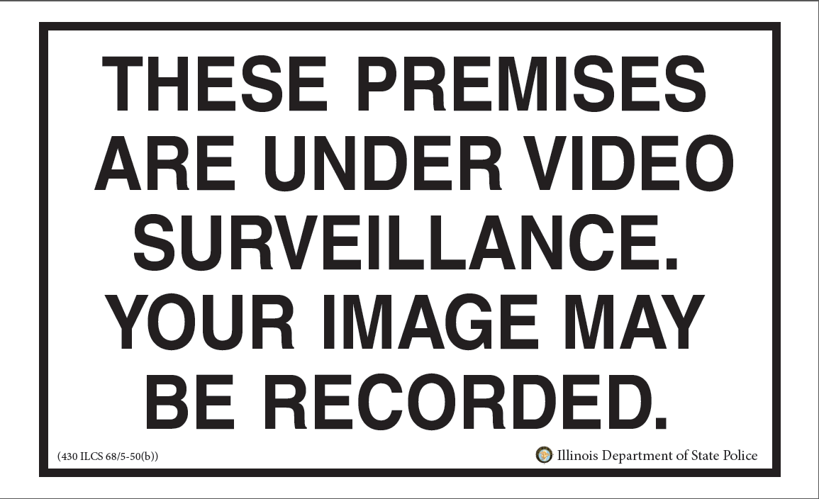
Illinois State Police

