Section 1125.APPENDIX C Regions of the Illinois Department of Public Health

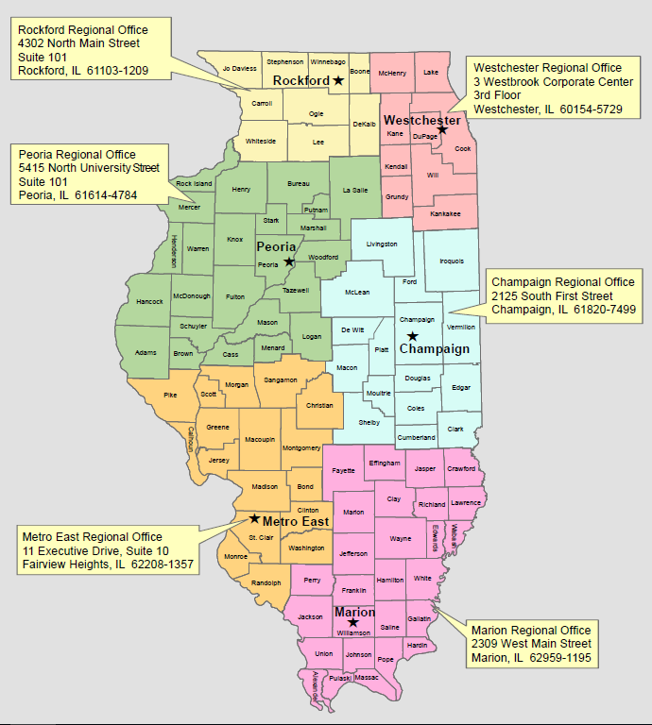

(Source: Amended at 49 Ill. Reg. 4626, effective March 25, 2025)

