Section 1125.APPENDIX B Current Organizational Chart

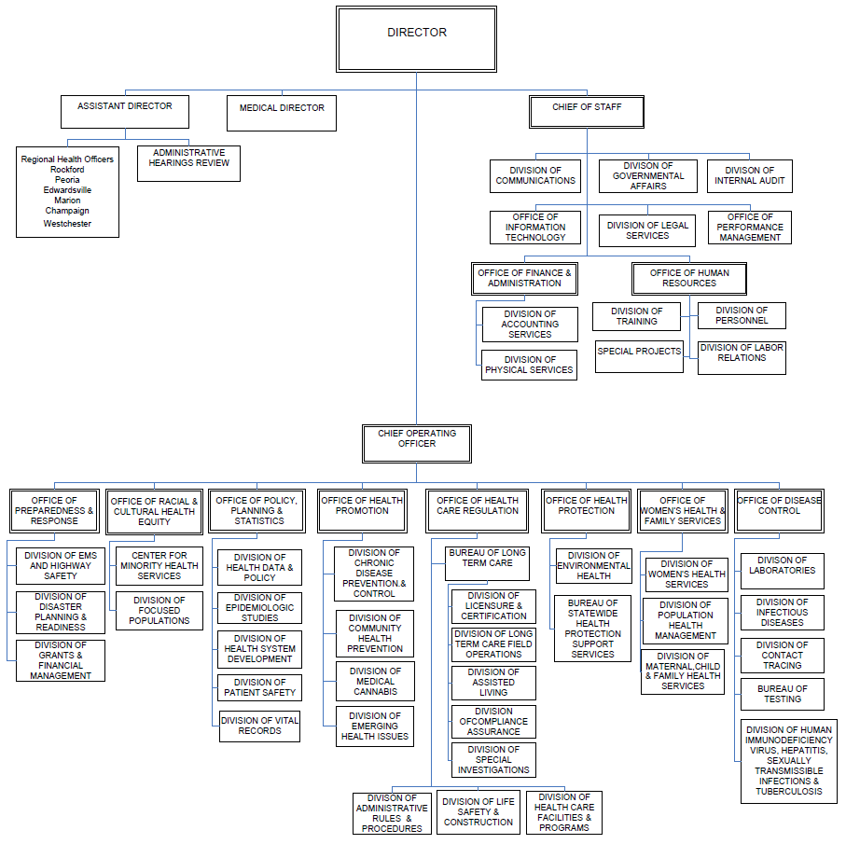

(Source: Amended at 49 Ill. Reg. 7029, effective May 5, 2025)

