Office of the Kane County State’s Attorney

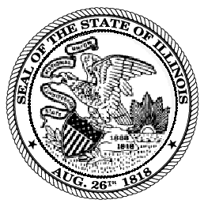
JAMIE L. MOSSER
State’s Attorney
Kane County Judicial Center General Offices:
37W777 Route 38 Suite 300 (630) 232-3500
St. Charles, Illinois 60175 Writer’s Direct Dial:
(630) 406-7538

March 27, 2023

To Whom It May Concern,

The purpose of this letter is to comply with the annual reporting requirements outlined in 725 ILCS 5/14-3(a)(3.10) for the year 2022. The Kane County State’s Attorney’s Office received 80 requests for the qualified offense of a felony violation of the Illinois Controlled Substances Act and 22 requests for the qualified offense of a felony violation of the Cannabis Control Act. All the requests were authorized.

If you have any questions, please contact me at (630) 232-3549.

Sincerely,

Jake G. Matekaitis
Assistant State’s Attorney

