December 16, 2021

Dear Honorable Members of the Illinois General Assembly:

On behalf of the Illinois Secure Choice Board, I am enclosing a copy of the Illinois Secure Choice Audit for Fiscal Year 2021 as required by Section 80(a) of the Illinois Secure Choice Savings Program Act (820 ILCS 80). This audit has also been provided to the Governor and Comptroller. This audit was conducted by Landmark, an independent certified public accountant firm, and was prepared in accordance with generally accepted accounting standards.

Thank you and Happy Holidays!

Sincerely,
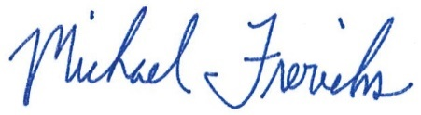

Michael W. Frerichs
Illinois State Treasurer
Chair, Illinois Secure Choice Savings Board

