STATE OF ILLINOIS
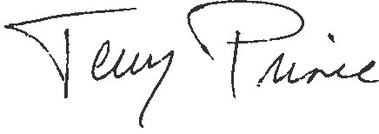
DEPARTMENT OF VETERANS’ AFFAIRS
833 South Spring Street, P.O. Box 19432, Springfield, IL 62794-9432
Telephone: 217-782-6641 * Fax: 217-524-0344

JB PRITZKER TERRY PRINCE
GOVERNOR ACTING DIRECTOR

July 30, 2021

Mr. John Hollman
Clerk of the House
420 State House
Springfield, IL 62706

Dear Mr. Hollman:

The Department of Veterans’ Affairs Act (20 ILCS 2805/15) directs the Illinois Veterans’ Advisory Council (IVAC) to report the following information to the General Assembly:

- Report to the Governor and the General Assembly
annually describing the issues addressed and the actions taken by the council during the year as well as any recommendations for future action.

On behalf of IVAC, we are sending this annual report to you to distribute to members of the Illinois House of Representatives. Enclosed with this document is the annual report for the Illinois Veterans’ Advisory Council.

Please let me know if you have any questions.

Sincerely,

Terry Prince

