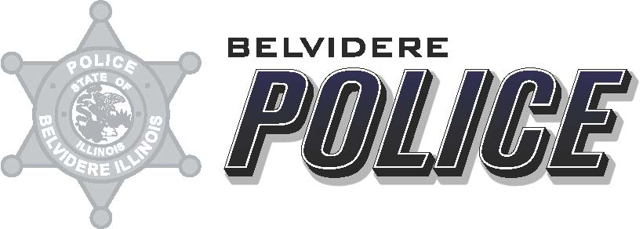

Date: March 9, 2023
From: Deputy Chief Matthew Wallace
To: ILETSB
Re: Camera Grant FY22 report

Attached are the reporting questions requested as a part of the ILETSB Camera Grant Award for year 2021.
- The Belvidere Police Department received 5 in-car cameras as a part of the ILETSB 2018 Camera Grant.
- The Belvidere Police Department received 15 in-car cameras as a part of the ILETSB 2019 Camera Grant.
- The Belvidere Police Department received 43 Body Worn Cameras as part of the ILETSB 2021 Camera Grant.
- The Belvidere Police Department had all 5 cameras installed in squad cars during year 2018. The Belvidere Police Department had all 15 cameras installed in squad cars during year 2019.
- The Belvidere Police Department had all 43 Body Worn Cameras implemented during year 2021.
- The supervisors and administrators of the Belvidere Police Department utilizes the In- Car cameras to review Use of Force, to review all pursuits, any officer complaints/ Internal Investigations, and as a general review of officer interaction with the public.
- The supervisors and administration of the Belvidere Police Department utilize the Body Worn Cameras in accordance with the laws of the State of Illinois. They are used as evidence in criminal cases. The videos are not reviewed for disciple purposes unless citizen complaints are filed.
- See Attached Excel spreadsheet.
- N/A

Respectfully Submitted,
Matthew R. Wallace
Deputy Chief
Belvidere Police Department

