December 19, 2018

Dear members of the General Assembly:

Pursuant to Public Act 100-0068, the DCFS is to submit a report to the General Assembly on the “implementation progress and recommendations for additional needed legislative changes” related to differential response program.

For the last few years, the Department has not administered a differential response program. However, at this time, such programming is being evaluated for potential implementation.

Sincerely,

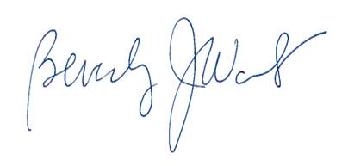

BJ Walker

Acting Director